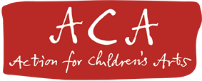
Brief for The Arts Backpack Feasibility Study - Action for Children’s Arts July 2018

Introducing the Idea

Action for Children’s Arts would like to commission an arts and cultural researcher to explore the idea of a virtual Arts Backpack being offered to every Primary School child in the UK. The Arts Backpack will serve as a digital collection point for all their Arts, Cultural, Heritage and Library engagements and experiences across the school year and our aim is to ensure that each child can access a minimum of 5 experiences.

It is neither new nor original, but one we feel would speak to every person in the UK in a clear and visible way.

ACA Introduction & Background

ACA is a small charity created initially to support all those artists who give their time and talent to children, 0-12yrs. We have been operating since 1998 and this year is our 20th birthday. Our funds are limited but we offer a unique ability to connect, alongside our ideas, our voice, and our belief in celebrating all that is good in our world of arts for children.

ACA’s charitable objective is ‘to further the artistic education of children by promoting and supporting all professional art forms for children under the age of 13, whilst bearing in mind children’s voices, wishes and needs’.

ACA is the national voice of children’s arts. We are dedicated to valuing children, valuing childhood and valuing the arts.

Through a programme of national and regional events and activities, ACA provides opportunities for artists, educators and other professionals working with children to exchange ideas and gain greater understanding of each other’s practice.

In essence we:
- Campaign for children’s right to the arts
- Connect children’s arts practitioners
- Celebrate children’s arts in the UK

Find out more about ACA here: http://www.childrensarts.org.uk

The Origin of the Arts Backpack Idea

The current climate is a very disappointing one with regard to the quantity and delivery of cultural education for all UK children. There are countless schemes and wonderfully motivated people who are working hard to provide arts for children, but for the person in the street, it is hard to keep up with what is happening.
Over the past 18 months we have been holding round table meetings with people from across the UK who listen to children and allow their ideas to inform their practise. As a result of these discussions, we would like to propose the idea of a virtual Arts Backpack for every primary school child across the UK. This is an initiative that will appeal to children, parents, carers and teachers in words and pictures they understand.

Identified Needs

We appreciate that Arts Councils, Creative and Cultural organisations across the UK, and educational and professional bodies such as the Royal Society for the Arts (RSA) are currently undertaking some limited research into the needs and benefits of cultural education. This may encourage the government to revise its approach, but meanwhile, we are responsible now for the first generation of Brexit children. We claim that children have a right to culture and cultural education and believe they have never needed it more to face the future, and to benefit their health and happiness.

We very much respect all that other organisations and charities do and highlight some of the organisations who, in ACA’s opinion, excel in their work with and for children in Appendix A.

We are also aware of other Cultural Offers which may offer interesting models for the Arts Backpack. Other cultural offers that will inform the development of the UK’s Arts Backpack:

- The Norwegian Cultural Rucksack http://www.kulturradet.no/documents/10157/a7464045-2cb6-4988-9948-ffd834508a5d
- The Israeli Cultural Breadbasket
http://www.culture.org.il/directory/culturalpolicy.asp
- The German Culture Rucksack, Nuremburg
https://www.theater-mummpitz.de/specials/nürnberger-kulturrucksack/idee/
- The Danish Culture Suitcase
https://english.kum.dk/policy-areas/children-and-youth-culture/
- Arts Bag, The Faroe Islands

Please see Appendix B for further information on these Cultural Offers.

The Feasibility Study – Why we are seeking to commission it

ACA want to commission a study examining the validity of the Arts Backpack idea. We plan to begin this study in Autumn 2018. The funded Feasibility Study (FS) will, among other targets, enable the creation of a national steering group and potentially regional steering groups. Key to the process will be the identification of a strong case to support it across the UK.

We wish to appeal to:
- Funded arts providers who could do more for children;
- Commercial providers who could do more for children;
- A selection of exemplary children's arts providers;
- Digital arts/children's learning providers;
- Politicians from across the UK with remits for Arts, Culture, Education, Digital, Health and Well-being; HE researchers working on, or who have published work looking at children and creativity or the impact of creativity in society;
- Leaders in understanding and assessing the impact of creative industries on UK GDP.

The Arts Backpack Feasibility Study will launch at the 20th Birthday Celebrations of our charity during an Impact Hour event in the Cottesloe Room at the English National Theatre in London on the morning of 4th August 2018. In the Impact Hour we will showcase the impact different kinds of arts activities and engagement have on children throughout the UK to an audience of invited arts, business and political leaders and in turn, invite them to pick up and run with this idea. Impact Hours could be hosted across the UK to launch the Backpack Challenge nationally.

The role of the Arts Business Consultant

We expect the Consultant to develop the FS over a 6 week period; the £4,000.00 fee offered covers all costs and expenses. The Consultant will be contracted as a freelance role with agreed and accepted responsibility for their own National Insurance and Income Tax. The Consultant will work independently with weekly agreed liaison with designated ACA Trustee(s).

Purpose of the Feasibility Study

The FS must offer clear reporting from a current review of published information and available literature related to the concept and scope of a UK wide initiative challenging all primary school children to connect with heritage, libraries, culture and the arts.

The Feasibility Study should address the following particular areas:

Research areas:
- International models of good practice
- Synergy to current UK programmes in Arts and Sports
- Current access and engagement levels/barrier to access for Arts and Cultural Events for primary school children across UK
- A review of current research pertinent to this idea
- Identified case for the educational, creative, emotional wellbeing, commercial and citizenship strengths that recommend this idea for support

Proposals for the Project’s Delivery and Management:
- An outline of the shape, format and scope of the project supported by the evidence gathered
- Project pilot options
- Project Timescale
- Digital and online engagement options
- Outline of funding and resources required for the pilot and expanded programme
- Regional and National Set Up options

Reflection and Continuity
- Project evaluation choices
- Overview of Sustainability highlighting any currently perceived risks.

Steering Group

The Advisory Group helping to steer the Arts Backpack idea is made up of the following children’s arts professionals:

Chris Abbott, Trustee - Action for Children’s Arts
Steve Ball, Associate Director - Birmingham Repertory Theatre
Eibhlin de Barra, Director - Young at Art
Kate Cross, Chair - Theatre for Young Audiences, UK
Mimi Doulton, Development Officer - Action for Children’s Arts
Matthew Gunn, Head - Cambridgeshire Music
Vicky Ireland, Chair - Action for Children’s Arts
Christopher Jarvis, Trustee - Action for Children’s Arts
Mark Powell, Artistic Director - Prime Theatre
Janet Robertson, Trustee - Action for Children’s Arts
Jane Sillis, Director - Engage
Thomas Small, Artistic Director - Shaper/Caper

Key milestones for study

- Interim report – end of week 3 of the FS period
- Draft report – beginning of week 5 of the FS period
- Final draft report - beginning of week 6 of the FS period.
- Final agreed report – at the end of week 6 of the FS period.

Report format

Copies of the report will be required on both digital and hardcopy formats.

Cost

The fee for completion of the Feasibility Study is £4,000.00 to include all expenses.

Payment Schedule

The agreed fee will be released in the following installments, subject to progress made:

20% following formal appointment
40% on completion of Interim report
40% on completion of Final agreed Report

Timescale

Role Advertised | 4 August 2018
Submission Deadline | 7 September 2108
Shortlist Deadline | 14 September 2018
Interviews & appointment during week of | 21 September 2018
Interim Report | 17 October 2018
Final Report | 6 November 2018

How to apply

Expressions of interest should be submitted electronically to:

Mimi Doulton, Development Director: mimi.doulton@childrensarts.org.uk

Expressions of interest should include:
- CV
- A statement of why the project is of interest to you
- Details of previous experience relevant to the project
- Contact details of 2 referees
This Feasibility Study has been generously supported by:

Arts Council Northern Ireland, Assitej UK, Belfast City Council, Cambridgeshire Music, Fife Council, Action for Children's Arts and two individuals.
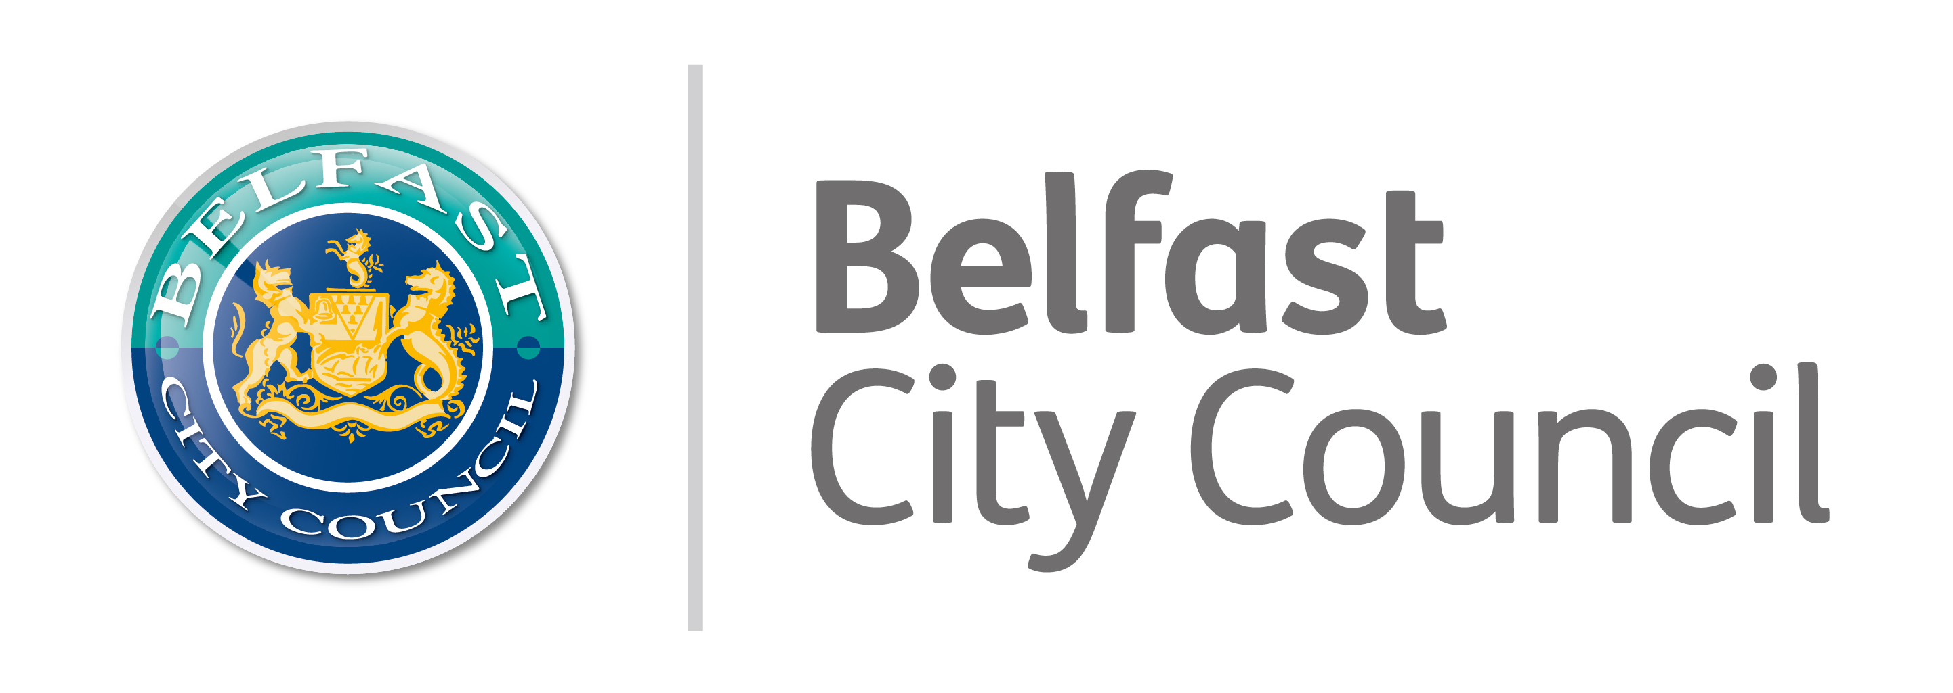
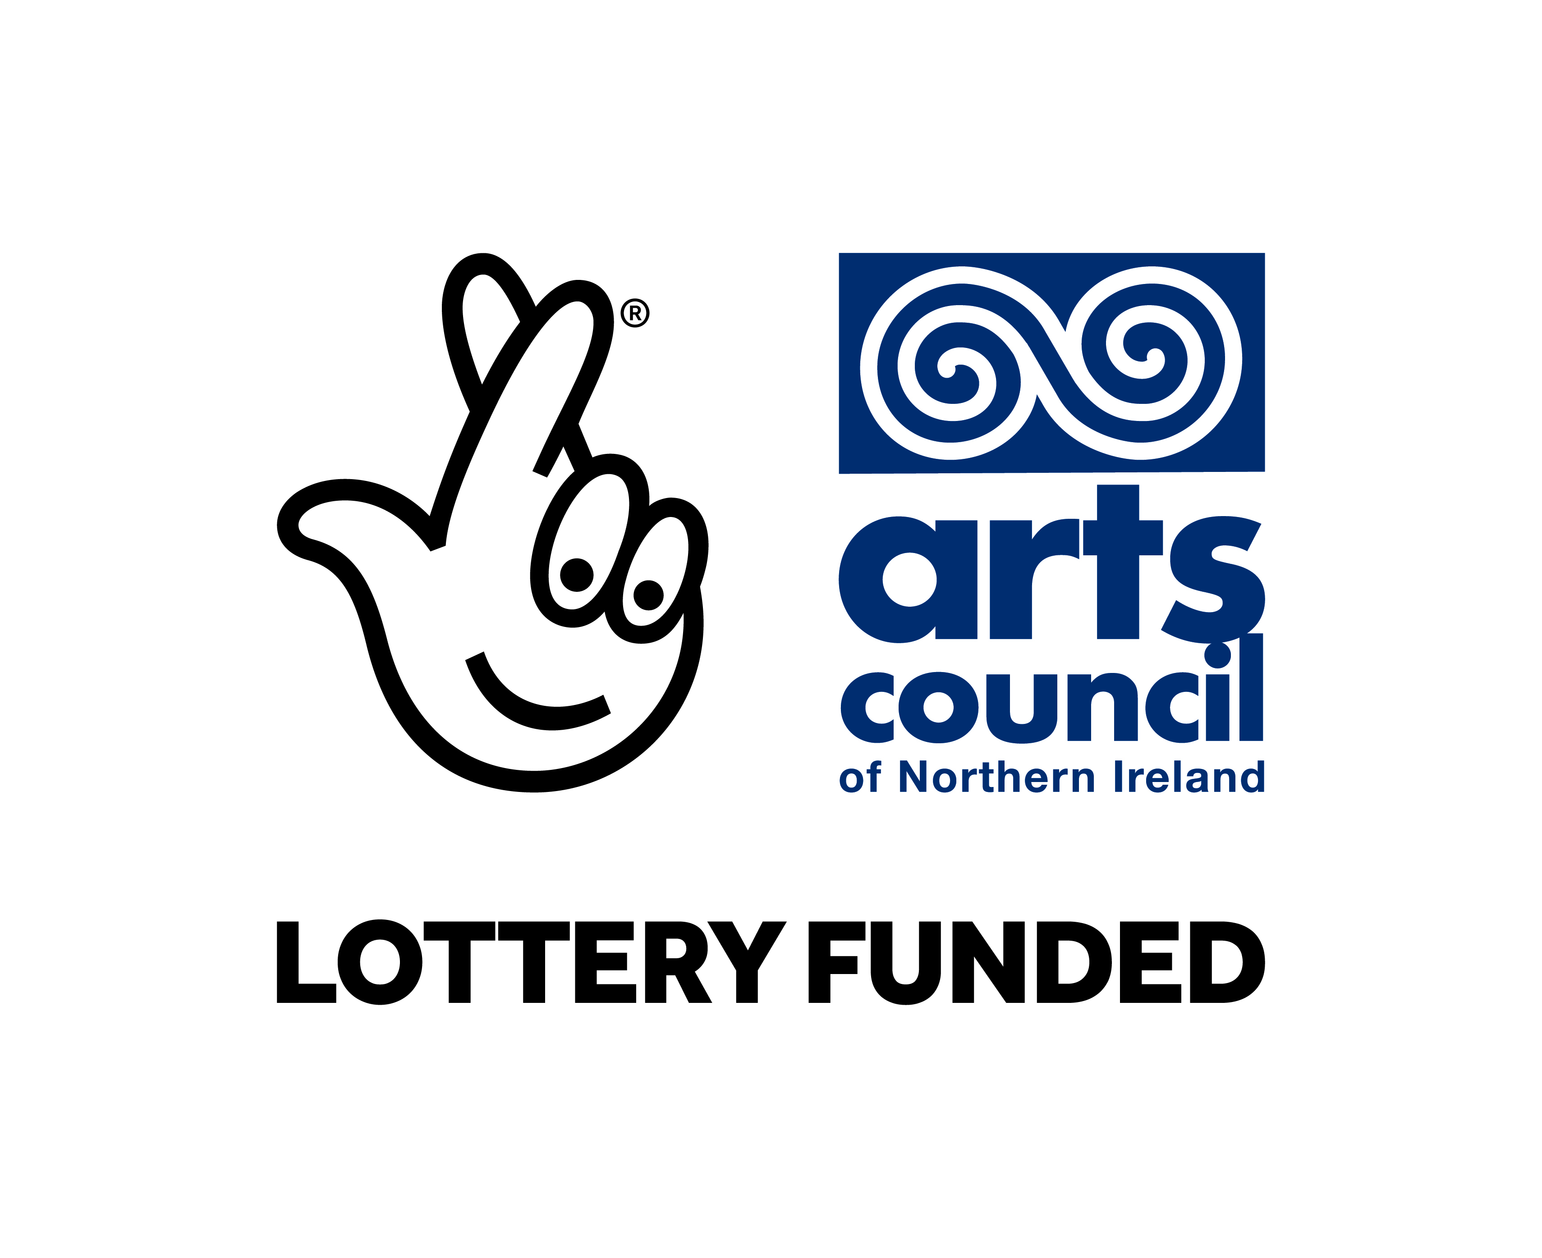

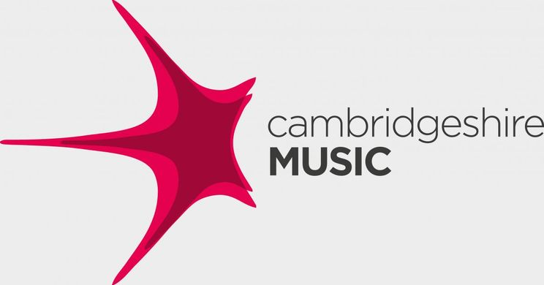
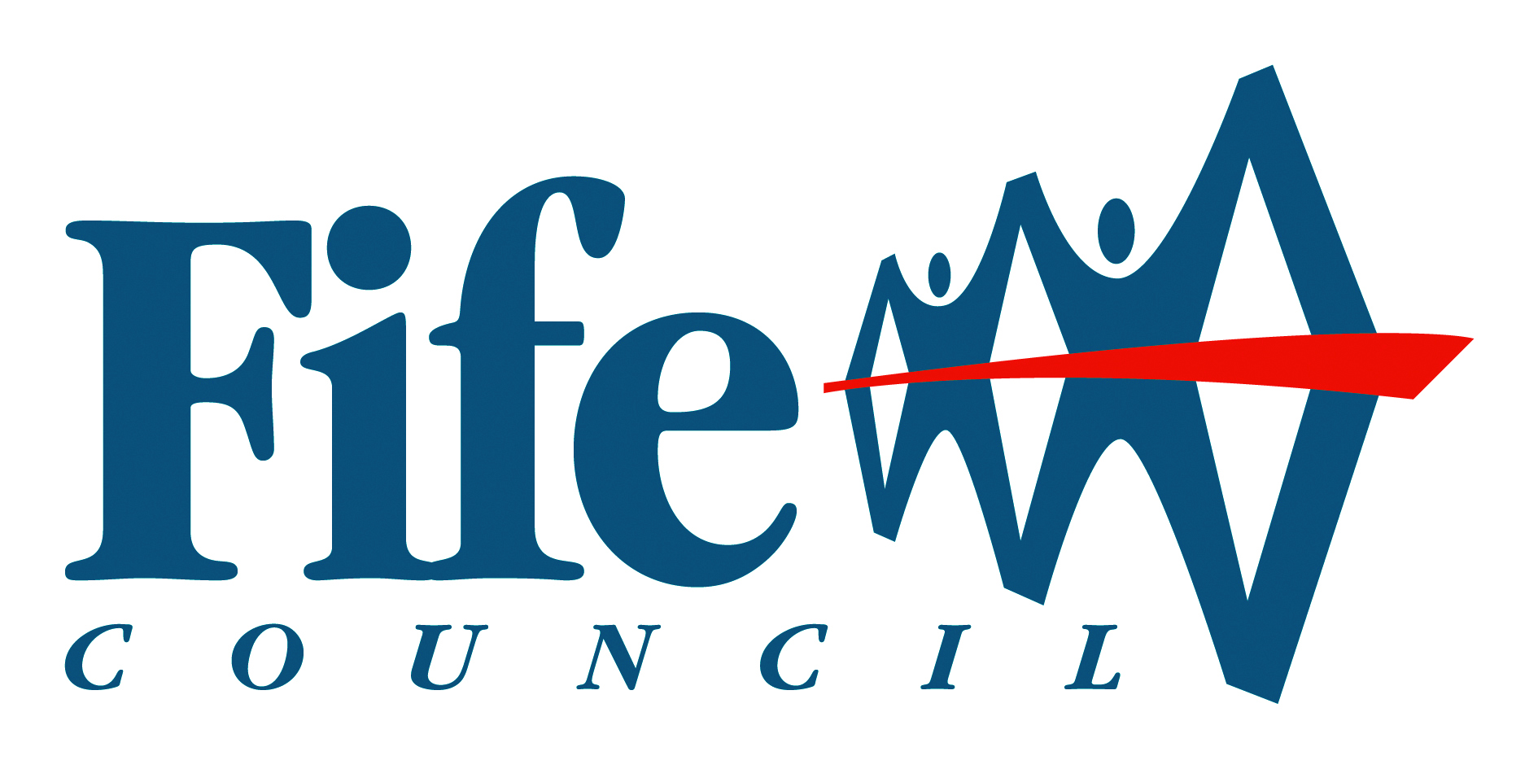
Appendix A

Organisations and charities who, in ACA’s opinion, excel in their work with and for children.
- Arts Mark
- Bridge organisations
- The Cultural Education Challenge
- The Paul Hamlyn, Education and Learning through the Arts
- The Cultural Learning Alliance
- ‘Let’s Play’, the English National Theatre
- ‘New Universal Culture Offer’ to Increase Engagement in Art and Culture, through Public Libraries
- Digital badging
- The Culture Card
- SOLT and UK Theatre ‘Inspiring the Future’, theatre ambassadors
and the work of organisations such as:
- Book Trust
- Engage
- Z Arts, Manchester
- The Spark Arts for Children, Leicester
- Mousetrap Theatre Projects
- The V&A
- Chickenshed
- The Big Draw
- Kids in Museums
- Imaginate, Scotland
- Sticky Fingers, NI
- Theatr Iolo, Wales
- Young at Art, NI
Appendix B

Other cultural offers that will inform the development of the UK’s Arts Backpack

- The Norwegian Cultural Rucksack

http://www.kulturradet.no/documents/10157/a7464045-2cb6-4988-9948-ffd834508a5d

Organisation and design Administration of the Cultural Rucksack is carried out at three levels: national (central government), regional (county authority), and local (municipality).

It asks art and cultural organisations, educational institutions and local authorities to come together to drive a joined-up art and cultural offer locally, to share resources and bring about a more coherent and visible delivery of cultural education through Local Cultural Education Partnerships.

At national level, the Ministry of Culture and the Ministry of Education and Research jointly define programme objectives, and instruments to achieve them. The Ministry of Culture is responsible for financing the programme and for following up allocations to ensure that funds are used as intended. Day-to-day responsibility lies with a secretariat under Arts Council Norway. The secretariat is responsible for administrative tasks, but does not determine the programme’s content. In practice, county authorities and municipalities plan and implement the Cultural Rucksack through their programming activities. Consequently, approaches to organising and implementing the programme often widely diverge.

At regional level, county authorities have a special responsibility for developing the programme. They administer most resources, and are responsible for offering artistic and cultural productions to municipalities. County authorities also help to develop the programme within municipalities, and are responsible for coordinating productions offered on a regional basis.

At local level, municipalities work together with county authorities to provide a cohesive programme for all schools. Municipalities own the schools, and must coordinate Cultural Rucksack activities with the schools’ curriculums. Between one third and two thirds of resources earmarked for the programme are allocated to municipalities by county authorities.

Arts Council Norway advises the government on cultural issues and is responsible for implementing Norwegian cultural policy.

2. The Israeli Cultural Breadbasket
http://www.culture.org.il/directory/culturalpolicy.asp

The cultural portfolio in Israel is currently administered by the Ministry of Education, Culture and Sports, which is based in Jerusalem. The key cultural arm of the Ministry is the Culture and Arts Administration (CAA), which works in close co-operation with three national institutions – the National Council for Culture and Arts, the Council of Museums and the Council of Public Libraries. The Ministry also incorporates a Religious Cultural Department which deals with the general development of Jewish culture, and an Orthodox Cultural Department which deals principally with the study of the Torah.

In Israel one of the most important agencies is Omanut La’am, which traces its origins back to a 1950s scheme to introduce Israeli culture to hundreds of thousands of new immigrants in the development towns and transit camps. Operating in close co-operation with the CAA, it funds a wide range of music, theatre, dance, literature, visual arts and film activities, touring them to outlying districts in conjunction with workshops and seminars aimed at making the arts more accessible to the general public.

Omanut La’am’s most interesting and successful project is the ‘Cultural Basket’ programme, which aims to introduce arts and culture to young Israelis, to encourage enjoyment of and participation in cultural activities from an early age and to foster the development of personal taste and the capacity for critical evaluation of art. The programme requires every child from kindergarten through to 12th grade to attend performances, art films and/or art exhibitions five or six times each year as part of their curriculum; 50% of the ticket cost is subsidised and transportation is arranged. The artistic activities of the ‘Cultural Basket’ are accompanied by educational materials for teachers and pupils, consultancy on educational matters and a series of study days.

Omanut La’am also organises various after-school activities at community-orientated schools.

3. The German Culture Rucksack, Nuremburg

https://www.theater-mummpitz.de/specials/nürnberger-kulturrucksack/idee/

In 2009/2010, the Theater Mummpitz and the city of Nuremberg set themselves the task of establishing and further developing the idea of ​​the "Culture Backpack" in Nuremberg. Since then, the Theater Mummpitz acts as an organizing cultural agency and mediating partner for the participating schools, cultural providers and sponsors. At the beginning of the school year, the participating third graders will receive a symbolic backpack filled with a selection from the varied cultural offerings of the city of Nuremberg. Contents of the backpack include theatre, museum, concert, exhibition, reading and dance event visits. These cultural excursions are meaningfully complemented by educational offers that are directly related to the events attended and in which the students can process and deepen their experiences. Each school year there are four different cultural outings and four in-depth educational workshops.

What does the Culture Rucksack bring?

The concrete implementation of the claim: children have a right to culture and cultural education. Regardless of the preferences and abilities of individual teachers or schools, each child receives a high-quality, varied range of services, which allows access to art and culture and many stimulating additions to everyday school life and reducing learning pressure. The participating Nuremberg cultural providers are strengthened and additionally encouraged to develop a child-friendly pedagogical supplement to their program and to offer what ultimately benefits all children. Lively mediation, genuine participation and pressure-free creativity for all!

How much is the Nuremberg Culture Backpack?

- A filled culture backpack for a child costs about 67 Euro per school year.
- A class set is to be financed for about 1500 Euro.
- A school sponsorship costs about 8000 Euro per year.
- The children contribute 10 euros for the whole school year.
The financing of the Nuremberg Culture Backpack is ensured by the promotion of the city of Nuremberg and the support of foundations, funds, sponsorship services of the local economy as well as private individuals.

4. Arts Bag, The Faroe Islands
This is a touring programme, bringing quality art to primary schools over the entire Faroe Islands.
5. The Danish Culture Suitcase

The initiative “Culture Suitcases” is aimed at children who have less access to art in their everyday life. The “Culture Suitcases” contain books, films and a pass that provides access to a range of local cultural activities. The initiative targets children in all age groups, from their cradle through to early adulthood.

6. Iceland and Croatia are also thinking about starting a similar idea.

